## S.5.5 Coefficient of variation heatmaps

*Figure S.5.5.1: heatmaps showing coefficient of variation (CV) values for dispersal in the all grasslands landscape under 12.1 °C (upper) and 15.05 °C (lower). Darker colours indicate higher CV values and therefore more variation in dispersal values.*

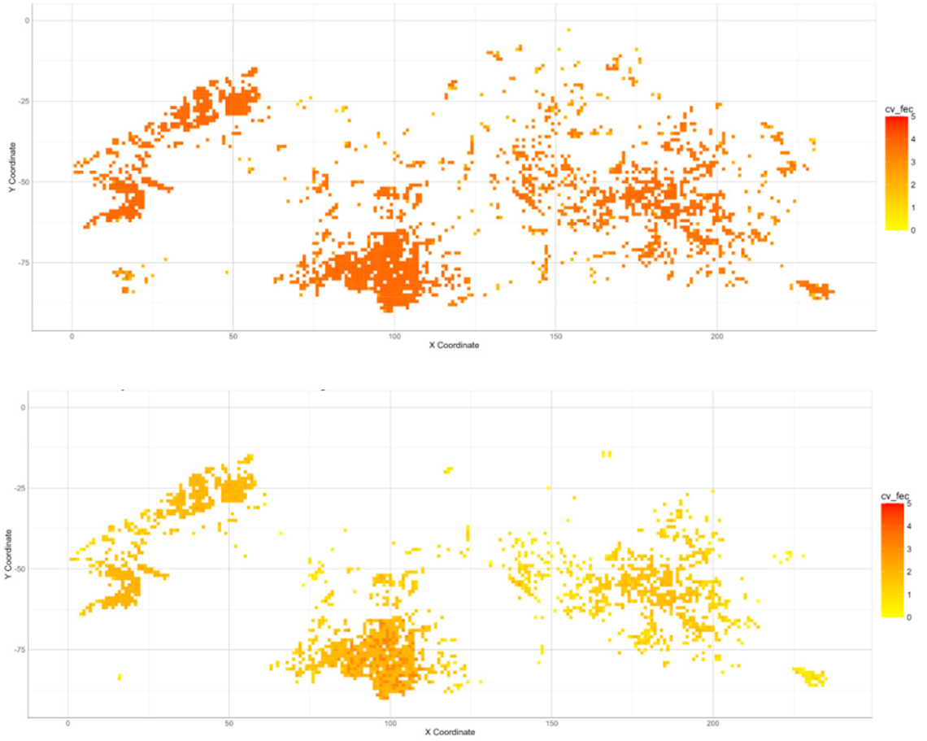

*Figure S.5.5.2: heatmaps showing coefficient of variation (CV) values for fecundity in the all grasslands landscape under 12.1 °C (upper) and 15.05 °C (lower). Darker colours indicate higher CV values and therefore more variation in fecundity values.*

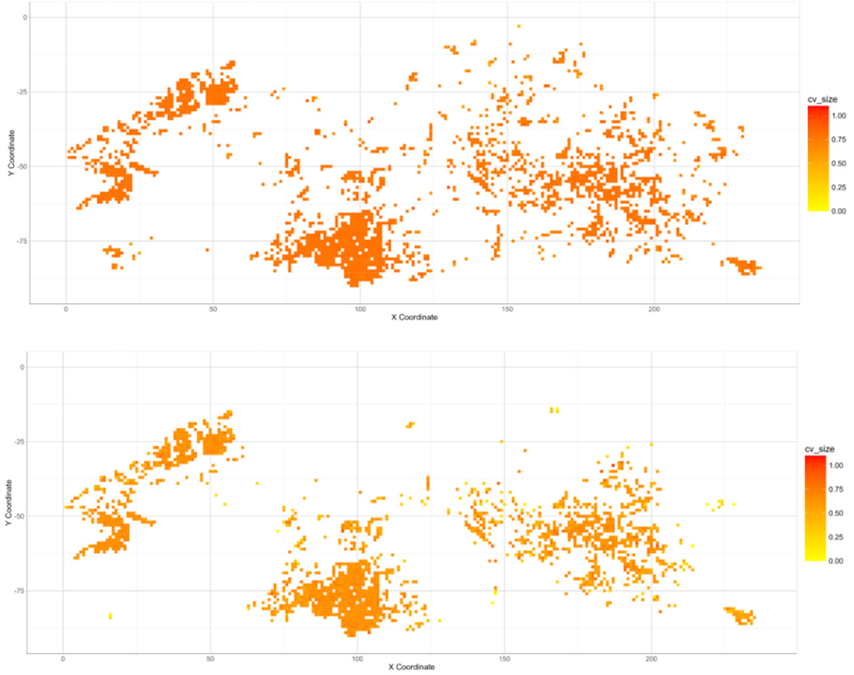

*Figure S.5.5.3: heatmaps showing coefficient of variation (CV) values for body size in the all grasslands landscape under 12.1 °C (upper) and 15.05 °C (lower). Darker colours indicate higher CV values and therefore more variation in size values.*

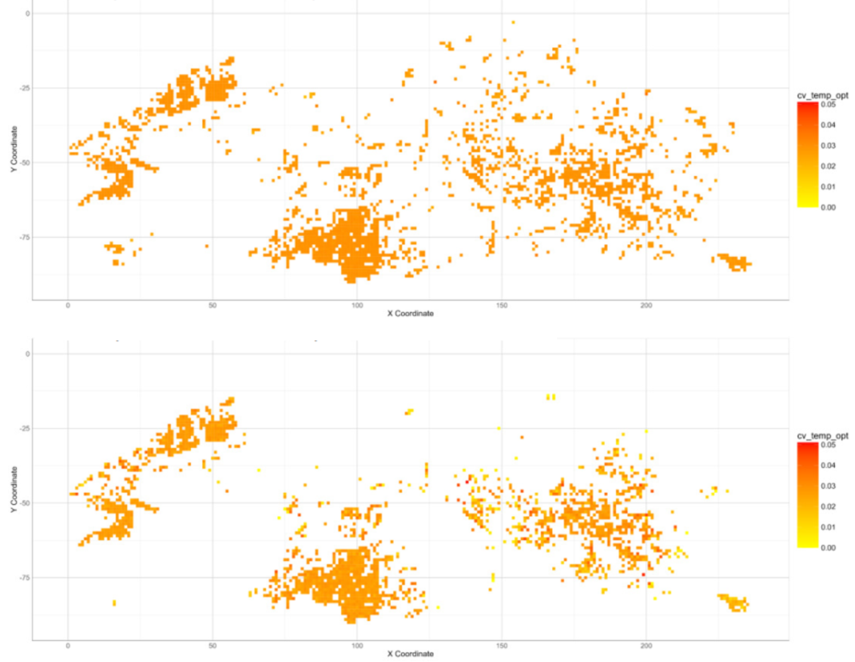

*Figure S.5.5.4: heatmaps showing coefficient of variation (CV) values for thermal optimum in the all grasslands landscape under 12.1 °C (upper) and 15.05 °C (lower). Darker colours indicate higher CV values and therefore more variation in thermal optimum values.*

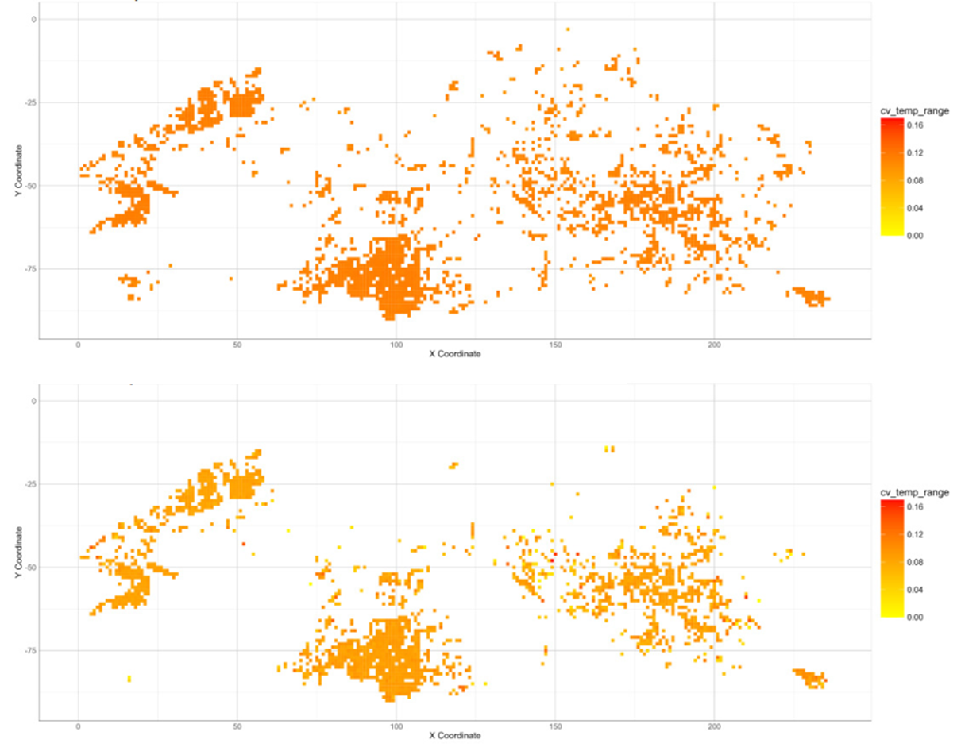

*Figure S.5.5.5: heatmaps showing coefficient of variation (CV) values for thermal breadth in the all grasslands landscape under 12.1 °C (upper) and 15.05 °C (lower). Darker colours indicate higher CV values and therefore more variation in thermal breadth values.*